UNITED STATES
SECURITIES AND EXCHANGE COMMISSION
Washington, D.C. 20549

FORM 8-K

CURRENT REPORT
Pursuant to Section 13 or 15(d) of the
Securities Exchange Act of 1934
Date of Report (Date of earliest event reported): October 14, 2026

Star Equity Holdings, Inc.
(Exact name of registrant as specified in charter)

Delaware |  |  |  |  |  | 001-38704 |  |  |  |  |  | 59-3547281
(State or other jurisdiction  of incorporation) |  |  |  |  |  | (Commission  File Number) |  |  |  |  |  | (I.R.S. Employer  Identification No.)

53 Forest Avenue, Suite 101
Old Greenwich, CT 06870
(Address of Principal Executive Offices)

Registrant's telephone number, including area code (203) 489-9500
N/A
(Former name or former address, if changed since last report)

Check the appropriate box below if the Form 8-K filing is intended to simultaneously satisfy the filing obligation of the registrant under any of the following provisions:

o |  |  | Written communications pursuant to Rule 425 under the Securities Act (17 CFR 230.425)

o |  |  | Soliciting material pursuant to Rule 14a-12 under the Exchange Act (17 CFR 240.14a-12)

o |  |  | Pre-commencement communications pursuant to Rule 14d-2(b) under the Exchange Act (17 CFR 240.14d-2(b))

o |  |  | Pre-commencement communications pursuant to Rule 13e-4(c) under the Exchange Act (17 CFR 240.13e-4(c)
Securities registered pursuant to Section 12(b) of the Act:
Title of each class |  |  | Trading Symbol(s) |  |  | Name of each exchange on which registered
Common Stock, $0.001 par value |  |  | STRR |  |  | The NASDAQ Stock Market LLC
Series A Preferred Stock, $0.001 par value |  |  | STRRP |  |  | The NASDAQ Stock Market LLC
Preferred Share Purchase Rights
Indicate by check mark whether the Registrant is an emerging growth company as defined in Rule 405 of the Securities Act of 1933 (§230.405 of this chapter) or Rule 12b-2 of the Securities Exchange Act of 1934 (§240.12b-2 of this chapter).

Emerging growth company ☐

If an emerging growth company, indicate by check mark if the Registrant has elected not to use the extended transition period for complying with any new or revised financial accounting standards provided pursuant to Section 13(a) of the Exchange Act. ☐

ITEM 7.01. |  |  | REGULATION FD DISCLOSURE.

Pursuant to Regulation FD, Star Equity Holdings, Inc. (the “Company”) hereby furnishes the investor presentation (the "Investor Presentation") relating to the Company’s business and operations as of June 30, 2026, which the Company made available on October 14, 2026, within the Investor Relations section of the Company’s website: www.starequity.com.

The information contained in the Investor Presentation is summary information that should be considered in the context of the Company’s filings with the Securities and Exchange Commission and other public announcements the Company may make by press release or otherwise from time to time. The Investor Presentation speaks as of the date of this report, and in accordance with the dates provided therein. While the Company may elect to update the Investor Presentation in the future to reflect events and circumstances occurring or existing after the date of this report, the Company specifically disclaims any obligation to do so.

A copy of the Investor Presentation is furnished herewith as Exhibits 99.1. The information furnished by the Company pursuant to this Item 7.01, including Exhibits 99.1, shall not be deemed “filed” for purposes of Section 18 of the Securities Exchange Act of 1934, as amended (the “Exchange Act”), or otherwise subject to the liability of that section, and shall not be deemed to be incorporated by reference into any Company filing under the Securities Act of 1933, as amended, or the Exchange Act, regardless of any general incorporation language in such filing.
ITEM 9.01. |  |  | FINANCIAL STATEMENTS AND EXHIBITS.

(d) Exhibits

EXHIBIT INDEX

99.1 |  |  | Investor Presentation, dated October 14, 2026
104 |  |  | Cover Page Interactive Data File (embedded within the Inline XBRL document)

1

SIGNATURES

Pursuant to the requirements of the Securities Exchange Act of 1934, the Registrant has duly caused this Report to be signed on its behalf by the undersigned hereunto duly authorized.

STAR EQUITY HOLDINGS, INC
(Registrant)
By: |  |  | /s/ MATTHEW K. DIAMOND
 |  |  | Matthew K. Diamond
 |  |  | Chief Accounting Officer
 |  |  | Dated: |  |  | October 14, 2026

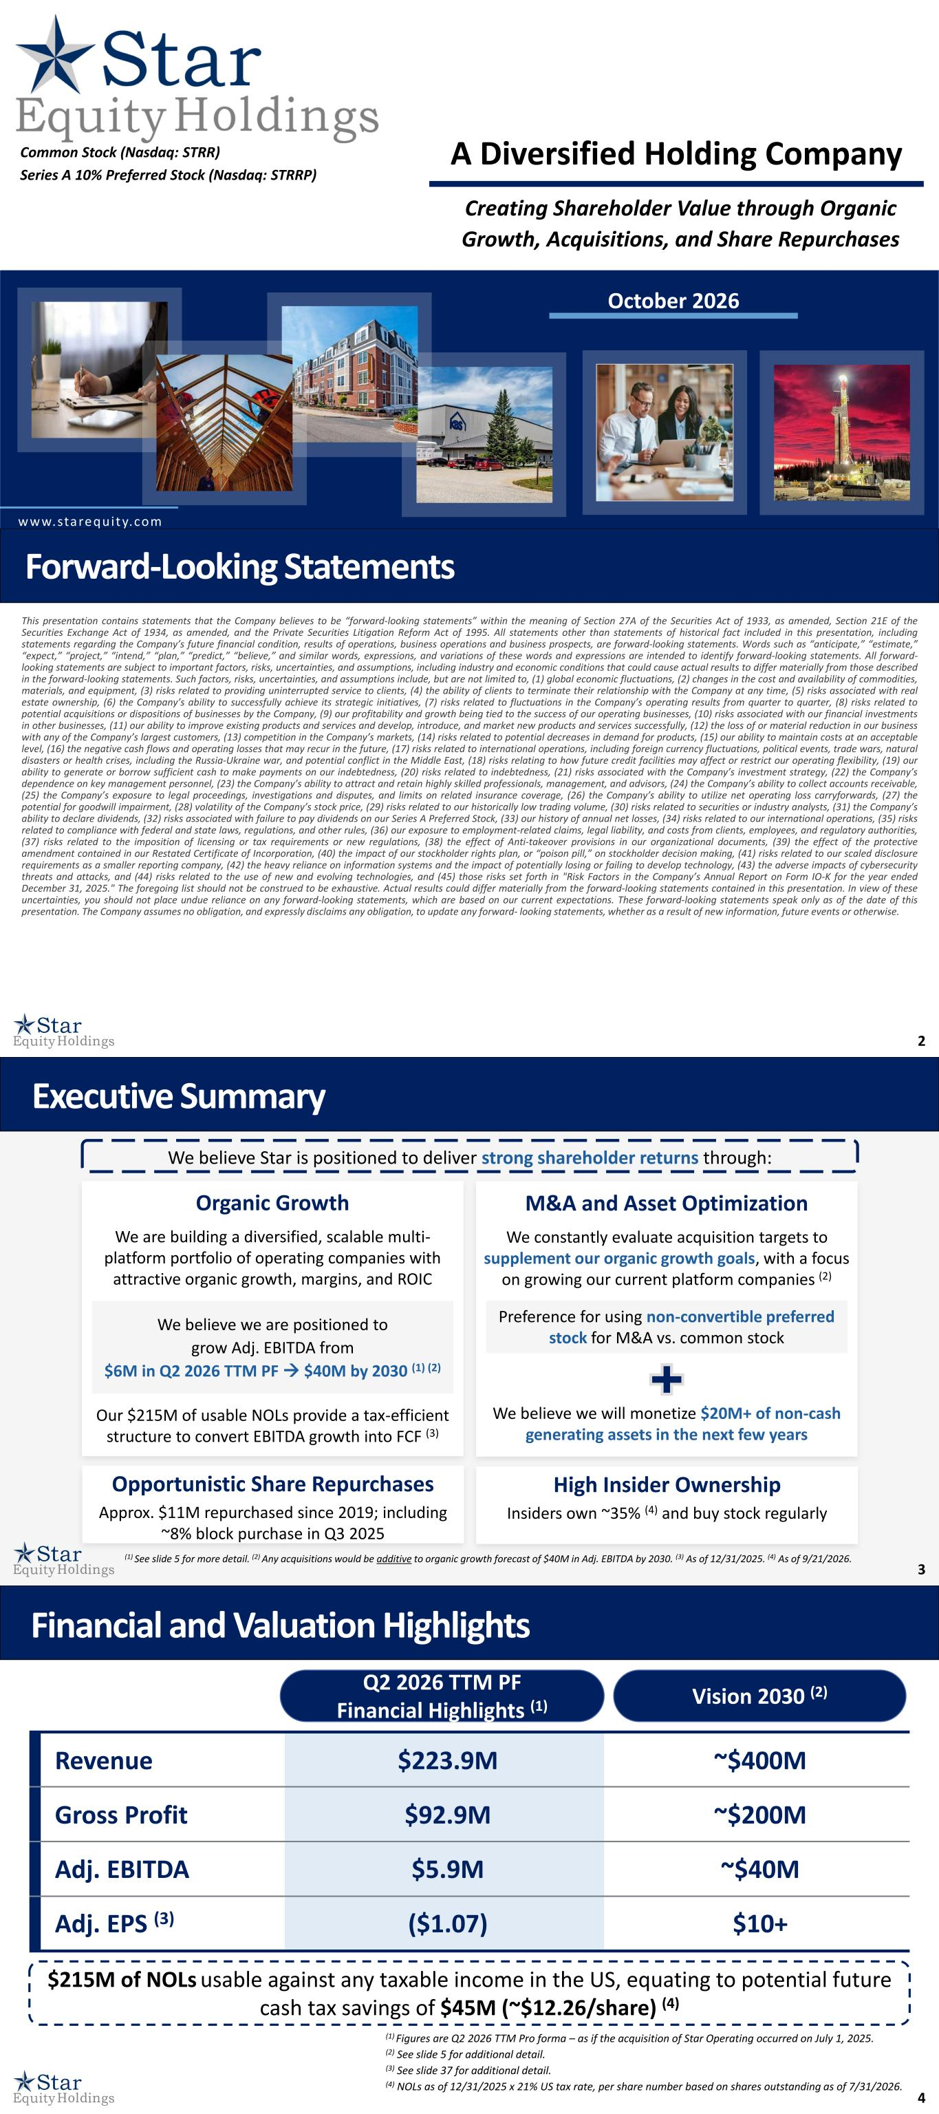
2
1 A Diversified Holding Company www.starequity.com Creating Shareholder Value through Organic Growth, Acquisitions, and Share Repurchases October 2026 Common Stock (Nasdaq: STRR) Series A 10% Preferred Stock (Nasdaq: STRRP) 2 This presentation contains statements that the Company believes to be “forward-looking statements” within the meaning of Section 27A of the Securities Act of 1933, as amended, Section 21E of the Securities Exchange Act of 1934, as amended, and the Private Securities Litigation Reform Act of 1995. All statements other than statements of historical fact included in this presentation, including statements regarding the Company’s future financial condition, results of operations, business operations and business prospects, are forward-looking statements. Words such as “anticipate,” “estimate,” “expect,” “project,” “intend,” “plan,” “predict,” “believe,” and similar words, expressions, and variations of these words and expressions are intended to identify forward-looking statements. All forward- looking statements are subject to important factors, risks, uncertainties, and assumptions, including industry and economic conditions that could cause actual results to differ materially from those described in the forward-looking statements. Such factors, risks, uncertainties, and assumptions include, but are not limited to, (1) global economic fluctuations, (2) changes in the cost and availability of commodities, materials, and equipment, (3) risks related to providing uninterrupted service to clients, (4) the ability of clients to terminate their relationship with the Company at any time, (5) risks associated with real estate ownership, (6) the Company’s ability to successfully achieve its strategic initiatives, (7) risks related to fluctuations in the Company’s operating results from quarter to quarter, (8) risks related to potential acquisitions or dispositions of businesses by the Company, (9) our profitability and growth being tied to the success of our operating businesses, (10) risks associated with our financial investments in other businesses, (11) our ability to improve existing products and services and develop, introduce, and market new products and services successfully, (12) the loss of or material reduction in our business with any of the Company’s largest customers, (13) competition in the Company’s markets, (14) risks related to potential decreases in demand for products, (15) our ability to maintain costs at an acceptable level, (16) the negative cash flows and operating losses that may recur in the future, (17) risks related to international operations, including foreign currency fluctuations, political events, trade wars, natural disasters or health crises, including the Russia-Ukraine war, and potential conflict in the Middle East, (18) risks relating to how future credit facilities may affect or restrict our operating flexibility, (19) our ability to generate or borrow sufficient cash to make payments on our indebtedness, (20) risks related to indebtedness, (21) risks associated with the Company’s investment strategy, (22) the Company’s dependence on key management personnel, (23) the Company’s ability to attract and retain highly skilled professionals, management, and advisors, (24) the Company’s ability to collect accounts receivable, (25) the Company’s exposure to legal proceedings, investigations and disputes, and limits on related insurance coverage, (26) the Company’s ability to utilize net operating loss carryforwards, (27) the potential for goodwill impairment, (28) volatility of the Company’s stock price, (29) risks related to our historically low trading volume, (30) risks related to securities or industry analysts, (31) the Company’s ability to declare dividends, (32) risks associated with failure to pay dividends on our Series A Preferred Stock, (33) our history of annual net losses, (34) risks related to our international operations, (35) risks related to compliance with federal and state laws, regulations, and other rules, (36) our exposure to employment-related claims, legal liability, and costs from clients, employees, and regulatory authorities, (37) risks related to the imposition of licensing or tax requirements or new regulations, (38) the effect of Anti-takeover provisions in our organizational documents, (39) the effect of the protective amendment contained in our Restated Certificate of Incorporation, (40) the impact of our stockholder rights plan, or “poison pill,” on stockholder decision making, (41) risks related to our scaled disclosure requirements as a smaller reporting company, (42) the heavy reliance on information systems and the impact of potentially losing or failing to develop technology, (43) the adverse impacts of cybersecurity threats and attacks, and (44) risks related to the use of new and evolving technologies, and (45) those risks set forth in "Risk Factors in the Company’s Annual Report on Form IO-K for the year ended December 31, 2025." The foregoing list should not be construed to be exhaustive. Actual results could differ materially from the forward-looking statements contained in this presentation. In view of these uncertainties, you should not place undue reliance on any forward-looking statements, which are based on our current expectations. These forward-looking statements speak only as of the date of this presentation. The Company assumes no obligation, and expressly disclaims any obligation, to update any forward- looking statements, whether as a result of new information, future events or otherwise. Forward-Looking Statements 3 Executive Summary (1) See slide 5 for more detail. (2) Any acquisitions would be additive to organic growth forecast of $40M in Adj. EBITDA by 2030. (3) As of 12/31/2025. (4) As of 9/21/2026. We believe Star is positioned to deliver strong shareholder returns through: Opportunistic Share Repurchases Approx. $11M repurchased since 2019; including ~8% block purchase in Q3 2025 Organic Growth We are building a diversified, scalable multi- platform portfolio of operating companies with attractive organic growth, margins, and ROIC Our $215M of usable NOLs provide a tax-efficient structure to convert EBITDA growth into FCF (3) We believe we are positioned to grow Adj. EBITDA from $6M in Q2 2026 TTM PF → $40M by 2030 (1) (2) M&A and Asset Optimization We constantly evaluate acquisition targets to supplement our organic growth goals, with a focus on growing our current platform companies (2) We believe we will monetize $20M+ of non-cash generating assets in the next few years Preference for using non-convertible preferred stock for M&A vs. common stock High Insider Ownership Insiders own ~35% (4) and buy stock regularly 4 $215M of NOLs usable against any taxable income in the US, equating to potential future cash tax savings of $45M (~$12.26/share) (4) Financial and Valuation Highlights (1) Figures are Q2 2026 TTM Pro forma – as if the acquisition of Star Operating occurred on July 1, 2025. (2) See slide 5 for additional detail. (3) See slide 37 for additional detail. (4) NOLs as of 12/31/2025 x 21% US tax rate, per share number based on shares outstanding as of 7/31/2026. $223.9M $92.9M $5.9M ($1.07) Revenue Gross Profit Adj. EBITDA Adj. EPS (3) ~$400M ~$200M ~$40M $10+ Q2 2026 TTM PF Financial Highlights (1) Vision 2030 (2)

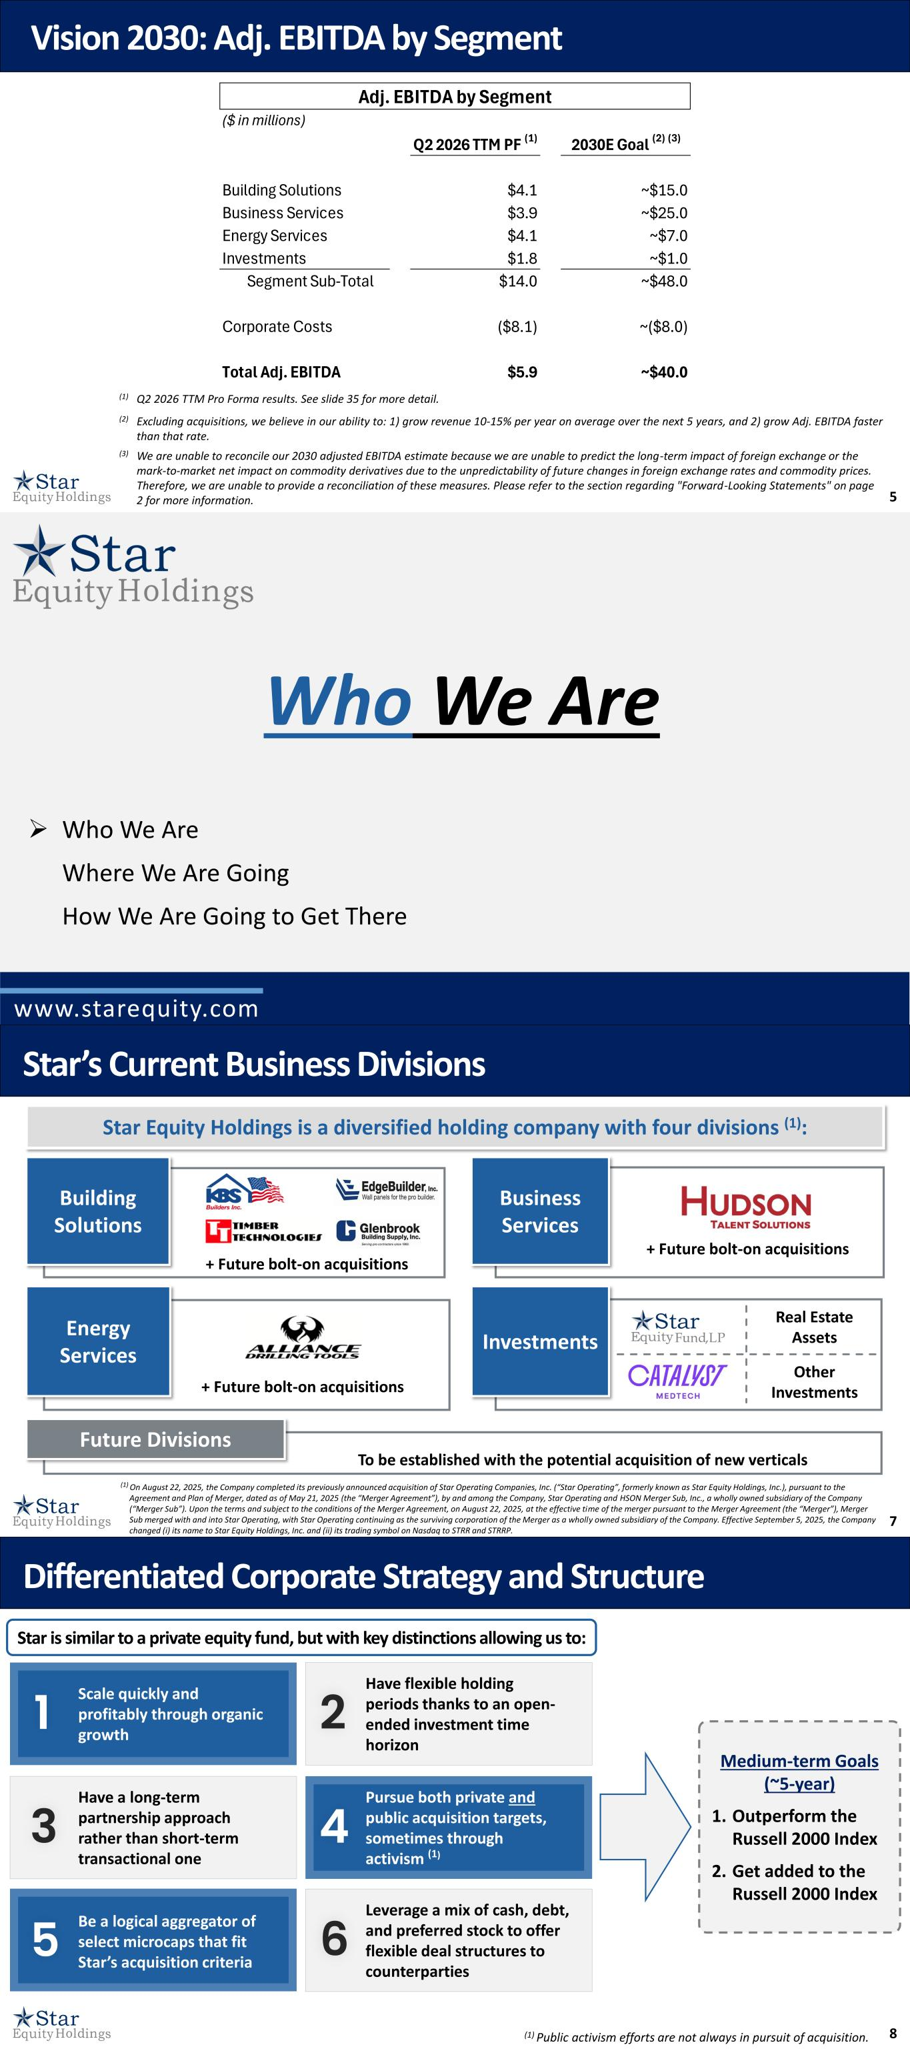
5 Vision 2030: Adj. EBITDA by Segment (3) We are unable to reconcile our 2030 adjusted EBITDA estimate because we are unable to predict the long-term impact of foreign exchange or the mark-to-market net impact on commodity derivatives due to the unpredictability of future changes in foreign exchange rates and commodity prices. Therefore, we are unable to provide a reconciliation of these measures. Please refer to the section regarding "Forward-Looking Statements" on page 2 for more information. (1) Q2 2026 TTM Pro Forma results. See slide 35 for more detail. (2) Excluding acquisitions, we believe in our ability to: 1) grow revenue 10-15% per year on average over the next 5 years, and 2) grow Adj. EBITDA faster than that rate. ($ in millions) Q2 2026 TTM PF (1) 2030E Goal (2) (3) Building Solutions $4.1 ~$15.0 Business Services $3.9 ~$25.0 Energy Services $4.1 ~$7.0 Investments $1.8 ~$1.0 Segment Sub-Total $14.0 ~$48.0 Corporate Costs ($8.1) ~($8.0) Total Adj. EBITDA $5.9 ~$40.0 Adj. EBITDA by Segment Who We Are www.starequity.com ➢ Who We Are Where We Are Going How We Are Going to Get There 7 Star Equity Holdings is a diversified holding company with four divisions (1): Investments Investments Future Divisions To be established with the potential acquisition of new verticals Business Services Building Solutions Building Solutions Business Services i i + Future bolt-on acquisitions + Future bolt-on acquisitions Star’s Current Business Divisions Other Investments Business Services Business Services Real Estate Assets Investments + Future bolt-on acquisitions Energy Services (1) On August 22, 2025, the Company completed its previously announced acquisition of Star Operating Companies, Inc. (“Star Operating”, formerly known as Star Equity Holdings, Inc.), pursuant to the Agreement and Plan of Merger, dated as of May 21, 2025 (the “Merger Agreement”), by and among the Company, Star Operating and HSON Merger Sub, Inc., a wholly owned subsidiary of the Company (“Merger Sub”). Upon the terms and subject to the conditions of the Merger Agreement, on August 22, 2025, at the effective time of the merger pursuant to the Merger Agreement (the “Merger”), Merger Sub merged with and into Star Operating, with Star Operating continuing as the surviving corporation of the Merger as a wholly owned subsidiary of the Company. Effective September 5, 2025, the Company changed (i) its name to Star Equity Holdings, Inc. and (ii) its trading symbol on Nasdaq to STRR and STRRP. 8(1) Public activism efforts are not always in pursuit of acquisition. Differentiated Corporate Strategy and Structure 1 Scale quickly and profitably through organic growth 3 5 Have a long-term partnership approach rather than short-term transactional one 2 4 Have flexible holding periods thanks to an open- ended investment time horizon 6Be a logical aggregator of select microcaps that fit Star’s acquisition criteria Star is similar to a private equity fund, but with key distinctions allowing us to: Leverage a mix of cash, debt, and preferred stock to offer flexible deal structures to counterparties Pursue both private and public acquisition targets, sometimes through activism (1) Medium-term Goals (~5-year) 1. Outperform the Russell 2000 Index 2. Get added to the Russell 2000 Index

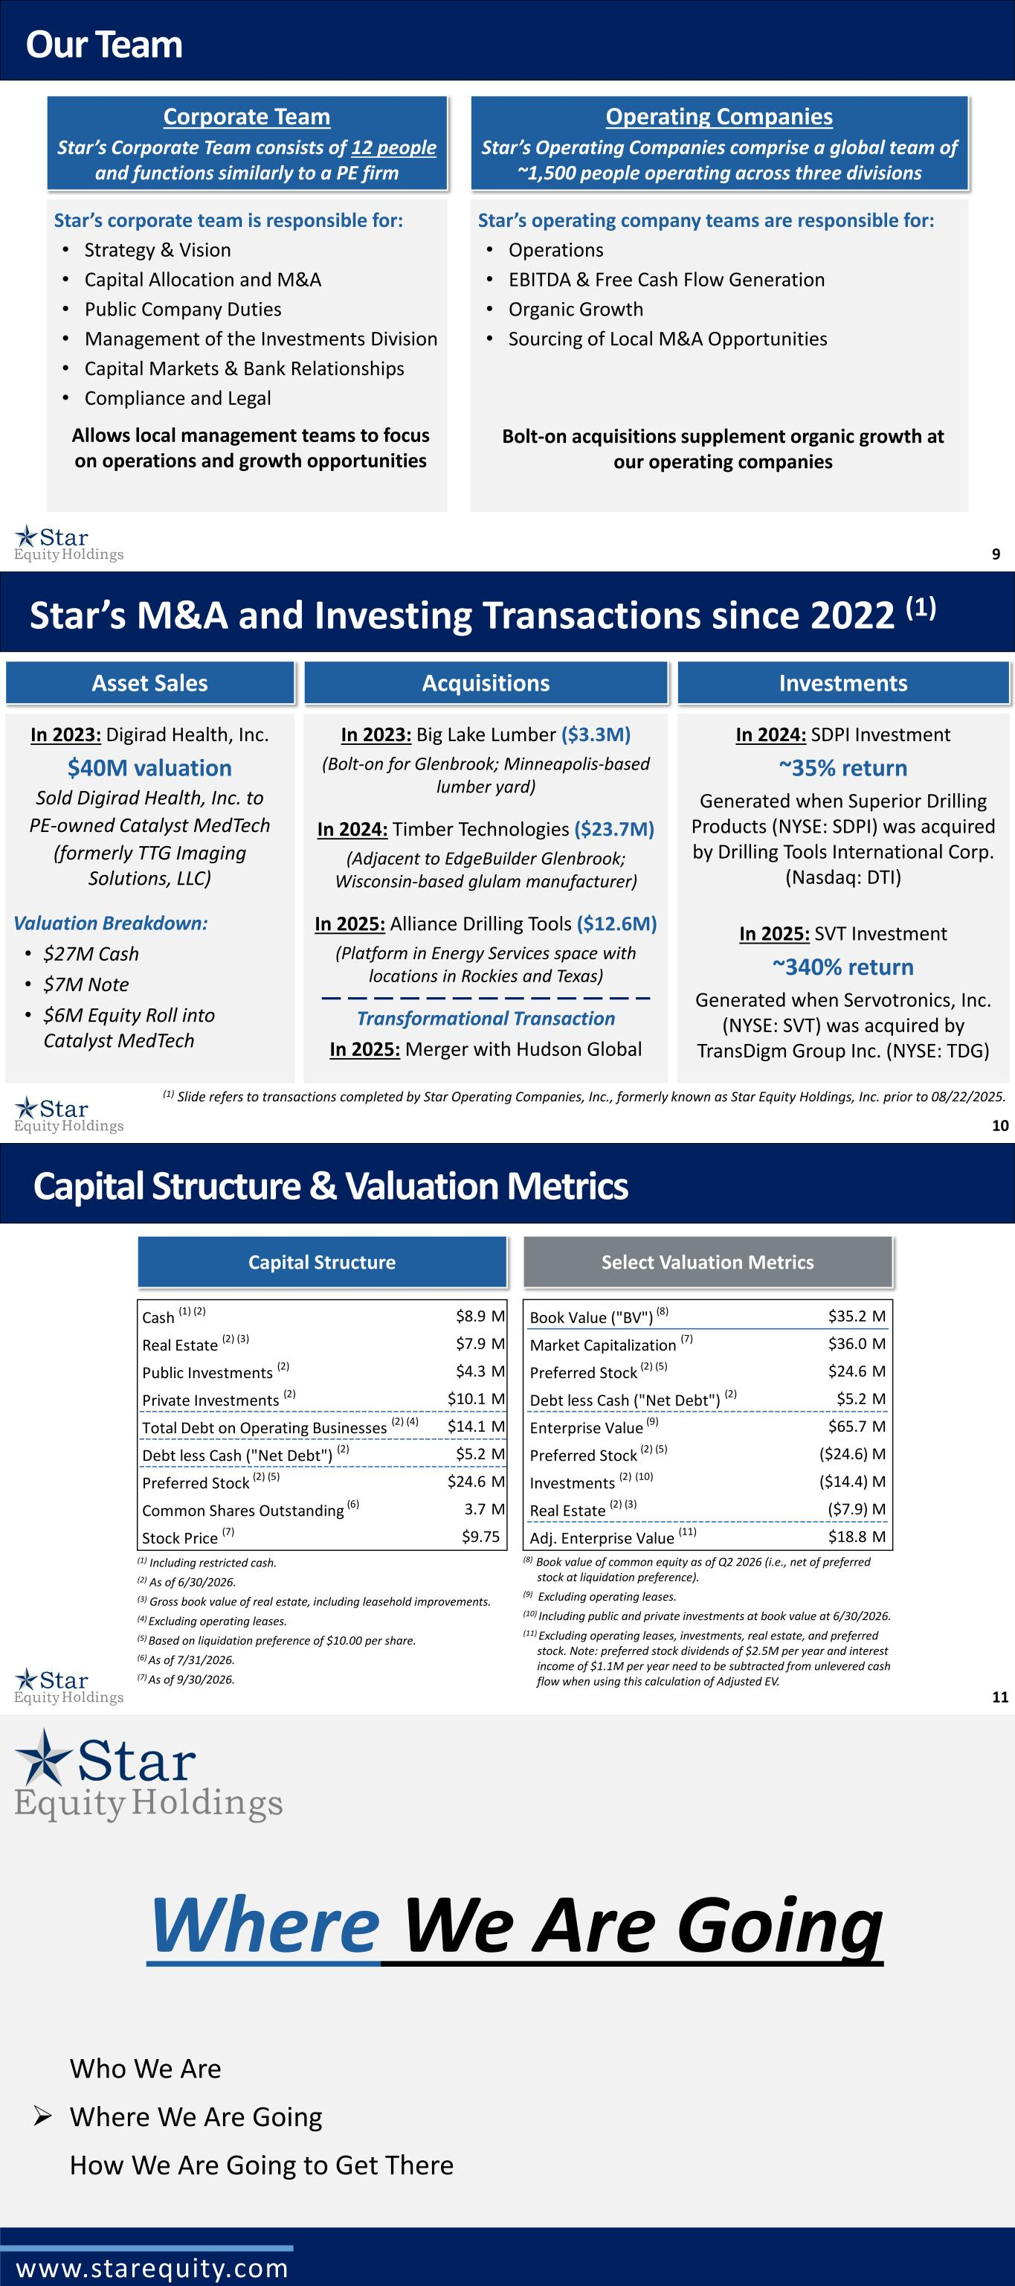
9 Our Team Star’s corporate team is responsible for: • Strategy & Vision • Capital Allocation and M&A • Public Company Duties • Management of the Investments Division • Capital Markets & Bank Relationships • Compliance and Legal Allows local management teams to focus on operations and growth opportunities Corporate Team Star’s Corporate Team consists of 12 people and functions similarly to a PE firm Star’s operating company teams are responsible for: • Operations • EBITDA & Free Cash Flow Generation • Organic Growth • Sourcing of Local M&A Opportunities Bolt-on acquisitions supplement organic growth at our operating companies Operating Companies Star’s Operating Companies comprise a global team of ~1,500 people operating across three divisions 10 Star’s M&A and Investing Transactions since 2022 (1) In 2023: Digirad Health, Inc. $40M valuation Sold Digirad Health, Inc. to PE-owned Catalyst MedTech (formerly TTG Imaging Solutions, LLC) Valuation Breakdown: • $27M Cash • $7M Note • $6M Equity Roll into Catalyst MedTech In 2024: SDPI Investment ~35% return Generated when Superior Drilling Products (NYSE: SDPI) was acquired by Drilling Tools International Corp. (Nasdaq: DTI) In 2025: SVT Investment ~340% return Generated when Servotronics, Inc. (NYSE: SVT) was acquired by TransDigm Group Inc. (NYSE: TDG) In 2023: Big Lake Lumber ($3.3M) (Bolt-on for Glenbrook; Minneapolis-based lumber yard) In 2024: Timber Technologies ($23.7M) (Adjacent to EdgeBuilder Glenbrook; Wisconsin-based glulam manufacturer) In 2025: Alliance Drilling Tools ($12.6M) (Platform in Energy Services space with locations in Rockies and Texas) Transformational Transaction In 2025: Merger with Hudson Global Asset Sales Acquisitions Investments (1) Slide refers to transactions completed by Star Operating Companies, Inc., formerly known as Star Equity Holdings, Inc. prior to 08/22/2025. 11 Capital Structure & Valuation Metrics (1) Including restricted cash. (2) As of 6/30/2026. (3) Gross book value of real estate, including leasehold improvements. (4) Excluding operating leases. (5) Based on liquidation preference of $10.00 per share. (6) As of 7/31/2026. (7) As of 9/30/2026. (8) Book value of common equity as of Q2 2026 (i.e., net of preferred stock at liquidation preference). (9) Excluding operating leases. (10) Including public and private investments at book value at 6/30/2026. (11) Excluding operating leases, investments, real estate, and preferred stock. Note: preferred stock dividends of $2.5M per year and interest income of $1.1M per year need to be subtracted from unlevered cash flow when using this calculation of Adjusted EV. Capital Structure Select Valuation Metrics Cash (1) (2) $8.9 M Real Estate (2) (3) $7.9 M Public Investments (2) $4.3 M Private Investments (2) $10.1 M Total Debt on Operating Businesses (2) (4) $14.1 M Debt less Cash ("Net Debt") (2) $5.2 M Preferred Stock (2) (5) $24.6 M Common Shares Outstanding (6) 3.7 M Stock Price (7) $9.75 Book Value ("BV") (8) $35.2 M Market Capitalization (7) $36.0 M Preferred Stock (2) (5) $24.6 M Debt less Cash ("Net Debt") (2) $5.2 M Enterprise Value (9) $65.7 M Preferred Stock (2) (5) ($24.6) M Investments (2) (10) ($14.4) M Real Estate (2) (3) ($7.9) M Adj. Enterprise Value (11) $18.8 M Where We Are Going www.starequity.com Who We Are ➢ Where We Are Going How We Are Going to Get There

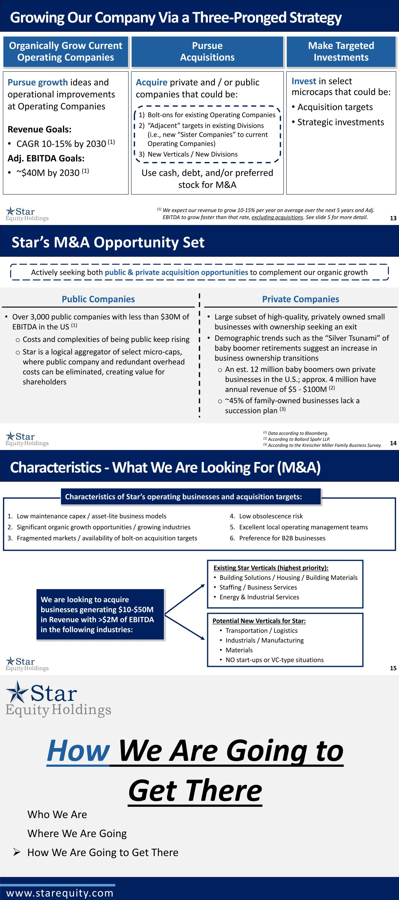
13 Growing Our Company Via a Three-Pronged Strategy (1) We expect our revenue to grow 10-15% per year on average over the next 5 years and Adj. EBITDA to grow faster than that rate, excluding acquisitions. See slide 5 for more detail. Organically Grow Current Operating Companies Make Targeted Investments Pursue Acquisitions Pursue growth ideas and operational improvements at Operating Companies Revenue Goals: • CAGR 10-15% by 2030 (1) Adj. EBITDA Goals: • ~$40M by 2030 (1) Invest in select microcaps that could be: • Acquisition targets • Strategic investments Acquire private and / or public companies that could be: Use cash, debt, and/or preferred stock for M&A 1) Bolt-ons for existing Operating Companies 2) “Adjacent” targets in existing Divisions (i.e., new “Sister Companies” to current Operating Companies) 3) New Verticals / New Divisions 14 Star’s M&A Opportunity Set (1) Data according to Bloomberg. (2) According to Ballard Spahr LLP. (3) According to the Kreischer Miller Family Business Survey. Public Companies • Over 3,000 public companies with less than $30M of EBITDA in the US (1) o Costs and complexities of being public keep rising o Star is a logical aggregator of select micro-caps, where public company and redundant overhead costs can be eliminated, creating value for shareholders Private Companies • Large subset of high-quality, privately owned small businesses with ownership seeking an exit • Demographic trends such as the “Silver Tsunami” of baby boomer retirements suggest an increase in business ownership transitions o An est. 12 million baby boomers own private businesses in the U.S.; approx. 4 million have annual revenue of $5 - $100M (2) o ~45% of family-owned businesses lack a succession plan (3) Actively seeking both public & private acquisition opportunities to complement our organic growth 15 Characteristics - What We Are Looking For (M&A) Characteristics of Star’s operating businesses and acquisition targets: Existing Star Verticals (highest priority): • Building Solutions / Housing / Building Materials • Staffing / Business Services • Energy & Industrial Services Potential New Verticals for Star: • Transportation / Logistics • Industrials / Manufacturing • Materials • NO start-ups or VC-type situations We are looking to acquire businesses generating $10-$50M in Revenue with >$2M of EBITDA in the following industries: 1. Low maintenance capex / asset-lite business models 2. Significant organic growth opportunities / growing industries 3. Fragmented markets / availability of bolt-on acquisition targets 4. Low obsolescence risk 5. Excellent local operating management teams 6. Preference for B2B businesses How We Are Going to Get There www.starequity.com Who We Are Where We Are Going ➢ How We Are Going to Get There

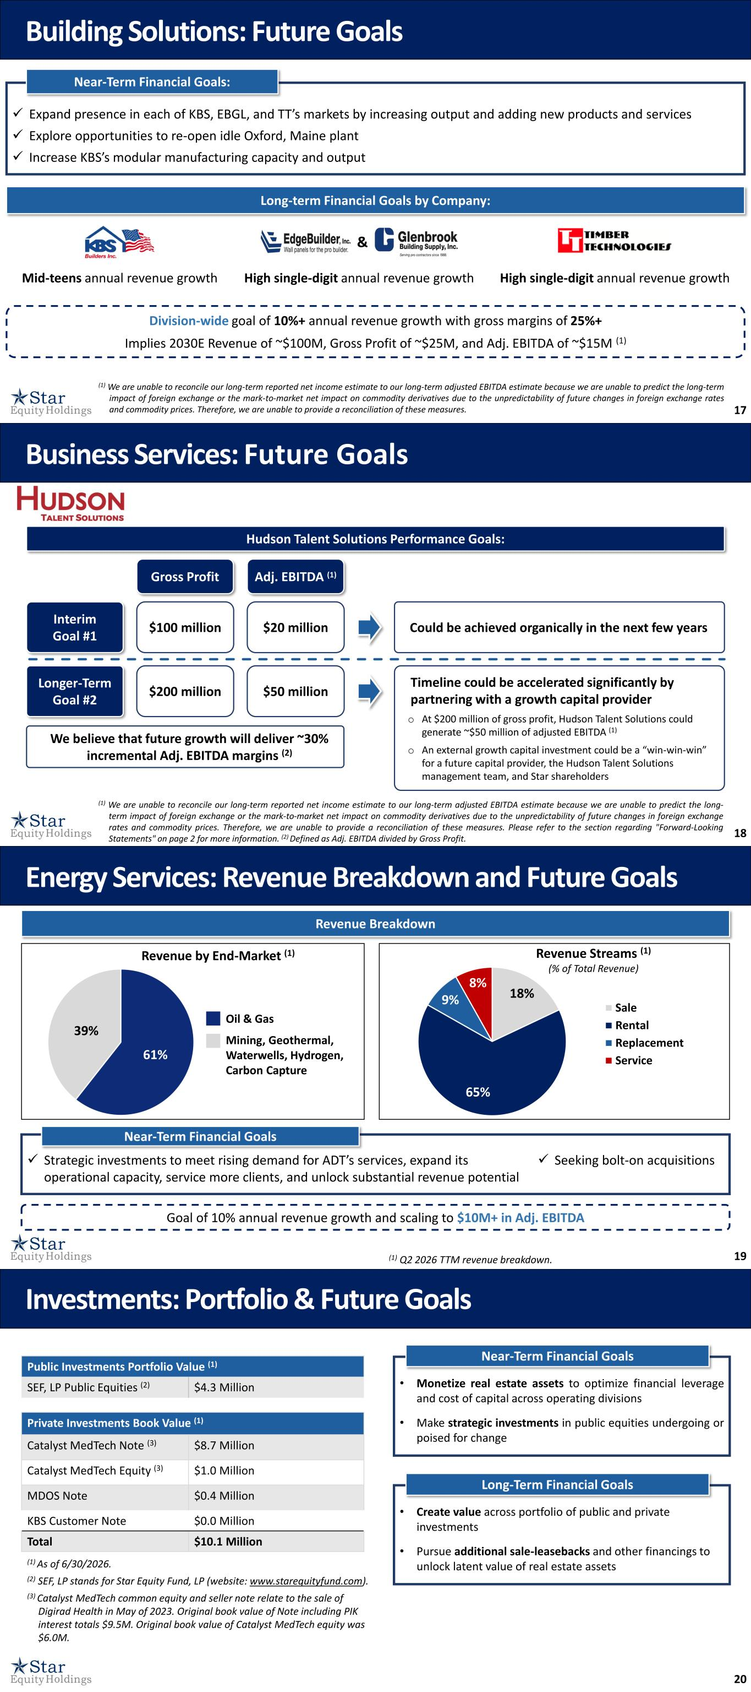
17 ✓ Expand presence in each of KBS, EBGL, and TT’s markets by increasing output and adding new products and services ✓ Explore opportunities to re-open idle Oxford, Maine plant ✓ Increase KBS’s modular manufacturing capacity and output Near-Term Financial Goals: Long-term Financial Goals by Company: Mid-teens annual revenue growth High single-digit annual revenue growthHigh single-digit annual revenue growth & Division-wide goal of 10%+ annual revenue growth with gross margins of 25%+ Implies 2030E Revenue of ~$100M, Gross Profit of ~$25M, and Adj. EBITDA of ~$15M (1) Building Solutions: Future Goals (1) We are unable to reconcile our long-term reported net income estimate to our long-term adjusted EBITDA estimate because we are unable to predict the long-term impact of foreign exchange or the mark-to-market net impact on commodity derivatives due to the unpredictability of future changes in foreign exchange rates and commodity prices. Therefore, we are unable to provide a reconciliation of these measures. 18 Interim Goal #1 Longer-Term Goal #2 $100 million $200 million $20 million $50 million Gross Profit Adj. EBITDA (1) Hudson Talent Solutions Performance Goals: Could be achieved organically in the next few years Timeline could be accelerated significantly by partnering with a growth capital provider o At $200 million of gross profit, Hudson Talent Solutions could generate ~$50 million of adjusted EBITDA (1) o An external growth capital investment could be a “win-win-win” for a future capital provider, the Hudson Talent Solutions management team, and Star shareholders Business Services: Future Goals We believe that future growth will deliver ~30% incremental Adj. EBITDA margins (2) (1) We are unable to reconcile our long-term reported net income estimate to our long-term adjusted EBITDA estimate because we are unable to predict the long- term impact of foreign exchange or the mark-to-market net impact on commodity derivatives due to the unpredictability of future changes in foreign exchange rates and commodity prices. Therefore, we are unable to provide a reconciliation of these measures. Please refer to the section regarding "Forward-Looking Statements" on page 2 for more information. (2) Defined as Adj. EBITDA divided by Gross Profit. 19 ✓ Strategic investments to meet rising demand for ADT’s services, expand its operational capacity, service more clients, and unlock substantial revenue potential ✓ Seeking bolt-on acquisitions Energy Services: Revenue Breakdown and Future Goals (1) Q2 2026 TTM revenue breakdown. Revenue Breakdown Oil & Gas Mining, Geothermal, Waterwells, Hydrogen, Carbon Capture Revenue by End-Market (1) Near-Term Financial Goals Goal of 10% annual revenue growth and scaling to $10M+ in Adj. EBITDA 18% 65% 9% 8% Revenue Streams (1) (% of Total Revenue) Sale Rental Replacement Service61% 39% 20 Private Investments Book Value (1) Catalyst MedTech Note (3) $8.7 Million Catalyst MedTech Equity (3) $1.0 Million MDOS Note $0.4 Million KBS Customer Note $0.0 Million Total $10.1 Million (1) As of 6/30/2026. (2) SEF, LP stands for Star Equity Fund, LP (website: www.starequityfund.com). (3) Catalyst MedTech common equity and seller note relate to the sale of Digirad Health in May of 2023. Original book value of Note including PIK interest totals $9.5M. Original book value of Catalyst MedTech equity was $6.0M. Long-Term Financial Goals • Create value across portfolio of public and private investments • Pursue additional sale-leasebacks and other financings to unlock latent value of real estate assets Near-Term Financial Goals • Monetize real estate assets to optimize financial leverage and cost of capital across operating divisions • Make strategic investments in public equities undergoing or poised for change Public Investments Portfolio Value (1) SEF, LP Public Equities (2) $4.3 Million Investments: Portfolio & Future Goals

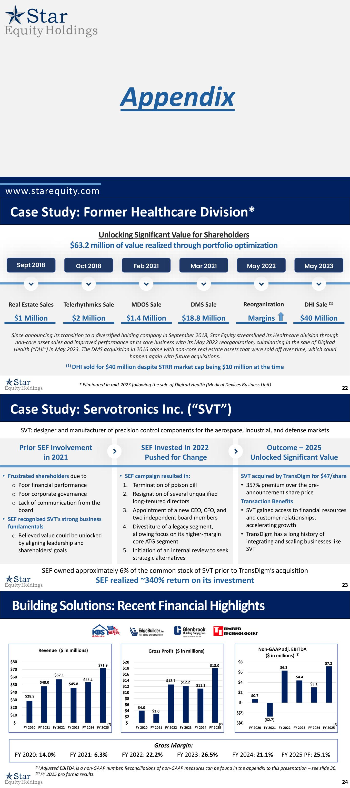
www.starequity.com Appendix 22 Case Study: Former Healthcare Division* Telerhythmics Sale $2 Million Reorganization Margins DMS Sale $18.8 Million MDOS Sale $1.4 Million DHI Sale (1) $40 Million Real Estate Sales $1 Million Feb 2021 Mar 2021 May 2022 May 2023Oct 2018Sept 2018 Since announcing its transition to a diversified holding company in September 2018, Star Equity streamlined its Healthcare division through non-core asset sales and improved performance at its core business with its May 2022 reorganization, culminating in the sale of Digirad Health (“DHI”) in May 2023. The DMS acquisition in 2016 came with non-core real estate assets that were sold off over time, which could happen again with future acquisitions. Unlocking Significant Value for Shareholders $63.2 million of value realized through portfolio optimization (1) DHI sold for $40 million despite STRR market cap being $10 million at the time * Eliminated in mid-2023 following the sale of Digirad Health (Medical Devices Business Unit) 23 Outcome – 2025 Unlocked Significant Value SVT acquired by TransDigm for $47/share • 357% premium over the pre- announcement share price Transaction Benefits • SVT gained access to financial resources and customer relationships, accelerating growth • TransDigm has a long history of integrating and scaling businesses like SVT SEF Invested in 2022 Pushed for Change • SEF campaign resulted in: 1. Termination of poison pill 2. Resignation of several unqualified long-tenured directors 3. Appointment of a new CEO, CFO, and two independent board members 4. Divestiture of a legacy segment, allowing focus on its higher-margin core ATG segment 5. Initiation of an internal review to seek strategic alternatives Prior SEF Involvement in 2021 • Frustrated shareholders due to o Poor financial performance o Poor corporate governance o Lack of communication from the board • SEF recognized SVT’s strong business fundamentals o Believed value could be unlocked by aligning leadership and shareholders’ goals Case Study: Servotronics Inc. (“SVT”) SVT: designer and manufacturer of precision control components for the aerospace, industrial, and defense markets SEF owned approximately 6% of the common stock of SVT prior to TransDigm’s acquisition SEF realized ~340% return on its investment 24 $28.9 $48.0 $57.1 $45.8 $53.4 $71.9 $- $10 $20 $30 $40 $50 $60 $70 $80 FY 2020 FY 2021 FY 2022 FY 2023 FY 2024 FY 2025 Revenue ($ in millions) $4.0 $3.0 $12.7 $12.2 $11.3 $18.0 $- $2 $4 $6 $8 $10 $12 $14 $16 $18 $20 FY 2020 FY 2021 FY 2022 FY 2023 FY 2024 FY 2025 Gross Profit ($ in millions) $0.7 ($2.7) $6.3 $4.4 $3.1 $7.2 $(4) $(2) $- $2 $4 $6 $8 FY 2020 FY 2021 FY 2022 FY 2023 FY 2024 FY 2025 Non-GAAP adj. EBITDA ($ in millions) (1) Gross Margin: FY 2020: 14.0% FY 2021: 6.3% FY 2022: 22.2% FY 2023: 26.5% FY 2024: 21.1% FY 2025 PF: 25.1% (1) Adjusted EBITDA is a non-GAAP number. Reconciliations of non-GAAP measures can be found in the appendix to this presentation – see slide 36. (2) FY 2025 pro forma results. (2) (2) (2) Building Solutions: Recent Financial Highlights

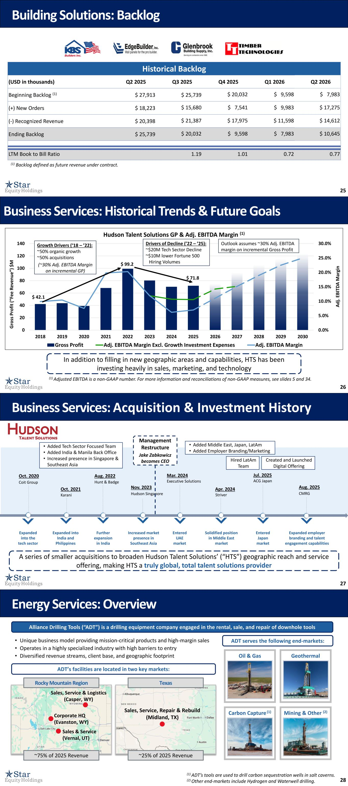
25 Building Solutions: Backlog Historical Backlog (USD in thousands) Q2 2025 Q3 2025 Q4 2025 Q1 2026 Q2 2026 Beginning Backlog (1) $ 27,913 $ 25,739 $ 20,032 $ 9,598 $ 7,983 (+) New Orders $ 18,223 $ 15,680 $ 7,541 $ 9,983 $ 17,275 (-) Recognized Revenue $ 20,398 $ 21,387 $ 17,975 $ 11,598 $ 14,612 Ending Backlog $ 25,739 $ 20,032 $ 9,598 $ 7,983 $ 10,645 LTM Book to Bill Ratio 1.19 1.01 0.72 0.77 (1) Backlog defined as future revenue under contract. 26 Business Services: Historical Trends & Future Goals In addition to filling in new geographic areas and capabilities, HTS has been investing heavily in sales, marketing, and technology 0.0% 5.0% 10.0% 15.0% 20.0% 25.0% 30.0% 0 20 40 60 80 100 120 140 2018 2019 2020 2021 2022 2023 2024 2025 2026 2027 2028 2029 2030 A d j. E B IT D A M ar gi n G ro ss P ro fi t (“ Fe e R ev e n u e ”) $ M Hudson Talent Solutions GP & Adj. EBITDA Margin (1) Gross Profit Adj. EBITDA Margin Excl. Growth Investment Expenses Adj. EBITDA Margin $ 99.2 $ 42.1 $ 71.8 Growth Drivers (‘18 – ’22): ~50% organic growth ~50% acquisitions (~30% Adj. EBITDA Margin on incremental GP) Drivers of Decline (’22 – ’25): ~$20M Tech Sector Decline ~$10M lower Fortune 500 Hiring Volumes Outlook assumes ~30% Adj. EBITDA margin on incremental Gross Profit (1) Adjusted EBITDA is a non-GAAP number. For more information and reconciliations of non-GAAP measures, see slides 5 and 34. 27 Business Services: Acquisition & Investment History ACG Japan Jul. 2025 Coit Group Oct. 2020 Karani Oct. 2021 Hunt & Badge Aug. 2022 Nov. 2023 Executive Solutions Mar. 2024 Striver Apr. 2024 CMRG Aug. 2025 Expanded into the tech sector Expanded into India and Philippines Further expansion in India Increased market presence in Southeast Asia Entered UAE market Solidified position in Middle East market Entered Japan market Expanded employer branding and talent engagement capabilities A series of smaller acquisitions to broaden Hudson Talent Solutions’ (“HTS”) geographic reach and service offering, making HTS a truly global, total talent solutions provider Hudson Singapore Management Restructure Jake Zabkowicz becomes CEO • Added Tech Sector Focused Team • Added India & Manila Back Office • Increased presence in Singapore & Southeast Asia • Added Middle East, Japan, LatAm • Added Employer Branding/Marketing Hired LatAm Team Created and Launched Digital Offering 28 Alliance Drilling Tools (“ADT”) is a drilling equipment company engaged in the rental, sale, and repair of downhole tools Energy Services: Overview Sales, Service & Logistics (Casper, WY) ADT’s facilities are located in two key markets: Mining & Other (2) Geothermal Carbon Capture (1) Oil & Gas Corporate HQ (Evanston, WY) Sales & Service (Vernal, UT) Rocky Mountain Region ~75% of 2025 Revenue Sales, Service, Repair & Rebuild (Midland, TX) Texas ~25% of 2025 Revenue ADT serves the following end-markets:• Unique business model providing mission-critical products and high-margin sales • Operates in a highly specialized industry with high barriers to entry • Diversified revenue streams, client base, and geographic footprint (1) ADT’s tools are used to drill carbon sequestration wells in salt caverns. (2) Other end-markets include Hydrogen and Waterwell drilling.

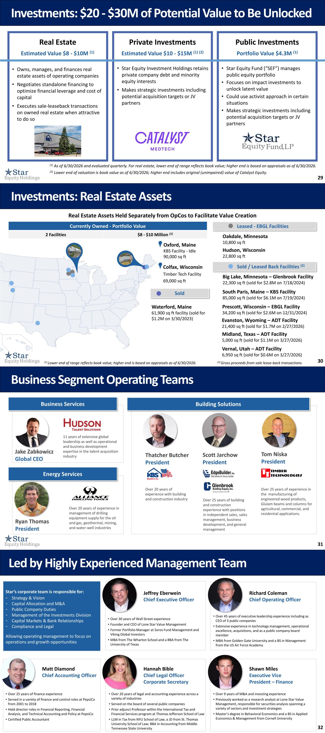
29 Private Investments • Star Equity Investment Holdings retains private company debt and minority equity interests • Makes strategic investments including potential acquisition targets or JV partners Investments: $20 - $30M of Potential Value to Be Unlocked Real Estate • Owns, manages, and finances real estate assets of operating companies • Negotiates standalone financing to optimize financial leverage and cost of capital • Executes sale-leaseback transactions on owned real estate when attractive to do so Public Investments • Star Equity Fund (“SEF”) manages public equity portfolio • Focuses on impact investments to unlock latent value • Could use activist approach in certain situations • Makes strategic investments including potential acquisition targets or JV partners Estimated Value $8 - $10M (1) Estimated Value $10 - $15M (1) (2) Portfolio Value $4.3M (1) (1) As of 6/30/2026 and evaluated quarterly. For real estate, lower end of range reflects book value; higher end is based on appraisals as of 6/30/2026. (2) Lower end of valuation is book value as of 6/30/2026; higher end includes original (unimpaired) value of Catalyst Equity. 30 Real Estate Assets Held Separately from OpCos to Facilitate Value Creation Big Lake, Minnesota – Glenbrook Facility 22,300 sq ft (sold for $2.8M on 7/18/2024) (1) Lower end of range reflects book value; higher end is based on appraisals as of 6/30/2026. Currently Owned - Portfolio Value 2 Facilities $8 - $10 Million (1) South Paris, Maine – KBS Facility 85,000 sq ft (sold for $6.1M on 7/19/2024) Waterford, Maine 61,900 sq ft facility (sold for $1.2M on 3/30/2023) Prescott, Wisconsin – EBGL Facility 34,200 sq ft (sold for $2.6M on 12/31/2024) Sold / Leased Back Facilities (2) Oakdale, Minnesota 10,800 sq ft Leased - EBGL Facilities Hudson, Wisconsin 22,800 sq ft Oxford, Maine KBS Facility - Idle 90,000 sq ft Colfax, Wisconsin Timber Tech Facility 69,000 sq ft Investments: Real Estate Assets Evanston, Wyoming – ADT Facility 21,400 sq ft (sold for $1.7M on 2/27/2026) (2) Gross proceeds from sale lease-back transactions. Vernal, Utah – ADT Facility 6,950 sq ft (sold for $0.6M on 3/27/2026) Midland, Texas – ADT Facility 5,000 sq ft (sold for $1.1M on 3/27/2026) Sold 31 Jake Zabkowicz Global CEO 11 years of extensive global leadership as well as operational and business development expertise in the talent acquisition industry Thatcher Butcher President Over 20 years of experience with building and construction industry Over 25 years of building and construction experience with positions in independent sales, sales management, business development, and general management Scott Jarchow President Over 20 years of experience in management of drilling equipment supply for the oil and gas, geothermal, mining, and water-well industries Ryan Thomas President Tom Niska President Over 25 years of experience in the manufacturing of engineered wood products, Glulam beams and columns for agricultural, commercial, and residential applications. Building SolutionsBusiness Services Energy Services Business Segment Operating Teams 32 Star’s corporate team is responsible for: - Strategy & Vision - Capital Allocation and M&A - Public Company Duties - Management of the Investments Division - Capital Markets & Bank Relationships - Compliance and Legal Allowing operating management to focus on operations and growth opportunities Led by Highly Experienced Management Team Jeffrey Eberwein Chief Executive Officer • Over 30 years of Wall Street experience • Founder and CEO of Lone Star Value Management • Former Portfolio Manager at Soros Fund Management and Viking Global Investors • MBA from The Wharton School and a BBA from The University of Texas Richard Coleman Chief Operating Officer • Over 45 years of executive leadership experience including as CEO of 3 public companies • Extensive experience in technology management, operational excellence, acquisitions, and as a public company board member • MBA from Golden Gate University and a BS in Management from the US Air Force Academy • Over 9 years of M&A and investing experience • Previously worked as a research analyst at Lone Star Value Management, responsible for securities analysis spanning a variety of sectors and investment strategies • Master’s degree in Behavioral Economics and a BS in Applied Economics & Management from Cornell University Shawn Miles Executive Vice President – Finance • Over 25 years of finance experience • Served in a variety of finance and control roles at PepsiCo from 2001 to 2018 • Held director roles in Financial Reporting, Financial Analysis, and Technical Accounting and Policy at PepsiCo • Certified Public Accountant Matt Diamond Chief Accounting Officer • Over 20 years of legal and accounting experience across a variety of industries • Served on the board of several public companies • Prior adjunct Professor within the International Tax and Financial Services program at Thomas Jefferson School of Law • LLM in Tax from NYU School of Law, a JD from St. Thomas University School of Law; BBA in Accounting from Middle Tennessee State University Hannah Bible Chief Legal Officer Corporate Secretary

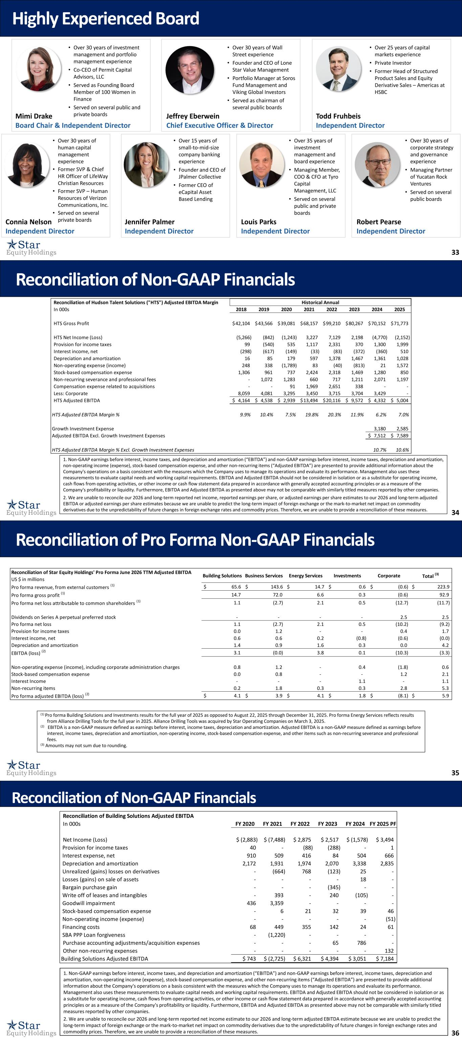
33 Highly Experienced Board Jeffrey Eberwein Chief Executive Officer & Director • Over 30 years of Wall Street experience • Founder and CEO of Lone Star Value Management • Portfolio Manager at Soros Fund Management and Viking Global Investors • Served as chairman of several public boards • Over 15 years of small-to-mid-size company banking experience • Founder and CEO of JPalmer Collective • Former CEO of eCapital Asset Based Lending Jennifer Palmer Independent Director Louis Parks Independent Director • Over 35 years of investment management and board experience • Managing Member, COO & CFO at Tyro Capital Management, LLC • Served on several public and private boards Todd Fruhbeis Independent Director • Over 25 years of capital markets experience • Private Investor • Former Head of Structured Product Sales and Equity Derivative Sales – Americas at HSBC Mimi Drake Board Chair & Independent Director • Over 30 years of investment management and portfolio management experience • Co-CEO of Permit Capital Advisors, LLC • Served as Founding Board Member of 100 Women in Finance • Served on several public and private boards Connia Nelson Independent Director • Over 30 years of human capital management experience • Former SVP & Chief HR Officer of LifeWay Christian Resources • Former SVP – Human Resources of Verizon Communications, Inc. • Served on several private boards Robert Pearse Independent Director • Over 30 years of corporate strategy and governance experience • Managing Partner of Yucatan Rock Ventures • Served on several public boards 34 Reconciliation of Non-GAAP Financials 1. Non-GAAP earnings before interest, income taxes, and depreciation and amortization (“EBITDA”) and non-GAAP earnings before interest, income taxes, depreciation and amortization, non-operating income (expense), stock-based compensation expense, and other non-recurring items (“Adjusted EBITDA”) are presented to provide additional information about the Company's operations on a basis consistent with the measures which the Company uses to manage its operations and evaluate its performance. Management also uses these measurements to evaluate capital needs and working capital requirements. EBITDA and Adjusted EBITDA should not be considered in isolation or as a substitute for operating income, cash flows from operating activities, or other income or cash flow statement data prepared in accordance with generally accepted accounting principles or as a measure of the Company's profitability or liquidity. Furthermore, EBITDA and Adjusted EBITDA as presented above may not be comparable with similarly titled measures reported by other companies. 2. We are unable to reconcile our 2026 and long-term reported net income, reported earnings per share, or adjusted earnings per share estimates to our 2026 and long-term adjusted EBITDA or adjusted earnings per share estimates because we are unable to predict the long-term impact of foreign exchange or the mark-to-market net impact on commodity derivatives due to the unpredictability of future changes in foreign exchange rates and commodity prices. Therefore, we are unable to provide a reconciliation of these measures. Reconciliation of Hudson Talent Solutions ("HTS") Adjusted EBITDA Margin In 000s 2018 2019 2020 2021 2022 2023 2024 2025 HTS Gross Profit 42,104$ 43,566$ 39,081$ 68,157$ 99,210$ 80,267$ 70,152$ 71,773$ HTS Net Income (Loss) (5,266) (842) (1,243) 3,227 7,129 2,198 (4,770) (2,152) Provision for income taxes 99 (540) 535 1,117 2,331 370 1,300 1,999 Interest income, net (298) (617) (149) (33) (83) (372) (360) 510 Depreciation and amortization 16 85 179 597 1,378 1,467 1,361 1,028 Non-operating expense (income) 248 338 (1,789) 83 (40) (813) 21 1,572 Stock-based compensation expense 1,306 961 737 2,424 2,318 1,469 1,280 850 Non-recurring severance and professional fees - 1,072 1,283 660 717 1,211 2,071 1,197 Compensation expense related to acquisitions - - 91 1,969 2,651 338 - - Less: Corporate 8,059 4,081 3,295 3,450 3,715 3,704 3,429 - HTS Adjusted EBITDA 4,164$ 4,538$ 2,939$ 13,494$ 20,116$ 9,572$ 4,332$ 5,004$ HTS Adjusted EBITDA Margin % 9.9% 10.4% 7.5% 19.8% 20.3% 11.9% 6.2% 7.0% Growth Investment Expense 3,180 2,585 Adjusted EBITDA Excl. Growth Investment Expenses 7,512$ 7,589$ HTS Adjusted EBITDA Margin % Excl. Growth Investment Expenses 10.7% 10.6% Historical Annual 35 Reconciliation of Pro Forma Non-GAAP Financials (1) Pro forma Building Solutions and Investments results for the full year of 2025 as opposed to August 22, 2025 through December 31, 2025. Pro forma Energy Services reflects results from Alliance Drilling Tools for the full year in 2025. Alliance Drilling Tools was acquired by Star Operating Companies on March 3, 2025. (2) EBITDA is a non-GAAP measure defined as earnings before interest, income taxes, depreciation and amortization. Adjusted EBITDA is a non-GAAP measure defined as earnings before interest, income taxes, depreciation and amortization, non-operating income, stock-based compensation expense, and other items such as non-recurring severance and professional fees. (3) Amounts may not sum due to rounding. Reconciliation of Star Equity Holdings' Pro Forma June 2026 TTM Adjusted EBITDA US $ in millions Building Solutions Business Services Energy Services Investments Corporate Total (3) Pro forma revenue, from external customers (1) $ 65.6 $ 143.6 $ 14.7 $ 0.6 $ (0.6) $ 223.9 Pro forma gross profit (1) 14.7 72.0 6.6 0.3 (0.6) 92.9 Pro forma net loss attributable to common shareholders (1) 1.1 (2.7) 2.1 0.5 (12.7) (11.7) Dividends on Series A perpetual preferred stock - - - - 2.5 2.5 Pro forma net loss 1.1 (2.7) 2.1 0.5 (10.2) (9.2) Provision for income taxes 0.0 1.2 - - 0.4 1.7 Interest income, net 0.6 0.6 0.2 (0.8) (0.6) (0.0) Depreciation and amortization 1.4 0.9 1.6 0.3 0.0 4.2 EBITDA (loss) (2) 3.1 (0.0) 3.8 0.1 (10.3) (3.3) Non-operating expense (income), including corporate administration charges 0.8 1.2 - 0.4 (1.8) 0.6 Stock-based compensation expense 0.0 0.8 - - 1.2 2.1 Interest Income - - - 1.1 - 1.1 Non-recurring items 0.2 1.8 0.3 0.3 2.8 5.3 Pro forma adjusted EBITDA (loss) (2) $ 4.1 $ 3.9 $ 4.1 $ 1.8 $ (8.1) $ 5.9 36 1. Non-GAAP earnings before interest, income taxes, and depreciation and amortization (“EBITDA”) and non-GAAP earnings before interest, income taxes, depreciation and amortization, non-operating income (expense), stock-based compensation expense, and other non-recurring items (“Adjusted EBITDA”) are presented to provide additional information about the Company's operations on a basis consistent with the measures which the Company uses to manage its operations and evaluate its performance. Management also uses these measurements to evaluate capital needs and working capital requirements. EBITDA and Adjusted EBITDA should not be considered in isolation or as a substitute for operating income, cash flows from operating activities, or other income or cash flow statement data prepared in accordance with generally accepted accounting principles or as a measure of the Company's profitability or liquidity. Furthermore, EBITDA and Adjusted EBITDA as presented above may not be comparable with similarly titled measures reported by other companies. 2. We are unable to reconcile our 2026 and long-term reported net income estimate to our 2026 and long-term adjusted EBITDA estimate because we are unable to predict the long-term impact of foreign exchange or the mark-to-market net impact on commodity derivatives due to the unpredictability of future changes in foreign exchange rates and commodity prices. Therefore, we are unable to provide a reconciliation of these measures. Reconciliation of Non-GAAP Financials Reconciliation of Building Solutions Adjusted EBITDA In 000s FY 2020 FY 2021 FY 2022 FY 2023 FY 2024 FY 2025 PF Net Income (Loss) $ (2,883) $ (7,488) $ 2,875 $ 2,517 $ (1,578) $ 3,494 Provision for income taxes 40 - (88) (288) - 1 Interest expense, net 910 509 416 84 504 666 Depreciation and amortization 2,172 1,931 1,974 2,070 3,338 2,835 Unrealized (gains) losses on derivatives - (664) 768 (123) 25 - Losses (gains) on sale of assets - - - - 18 - Bargain purchase gain - - - (345) - - Write off of leases and intangibles - 393 - 240 (105) - Goodwill impairment 436 3,359 - - - - Stock-based compensation expense - 6 21 32 39 46 Non-operating income (expense) - - - - - (51) Financing costs 68 449 355 142 24 61 SBA PPP Loan forgiveness - (1,220) - - - - Purchase accounting adjustments/acquisition expenses - - - 65 786 - Other non-recurring expenses - - - - - 132 Building Solutions Adjusted EBITDA $ 743 $ (2,725) $ 6,321 $ 4,394 $ 3,051 $ 7,184

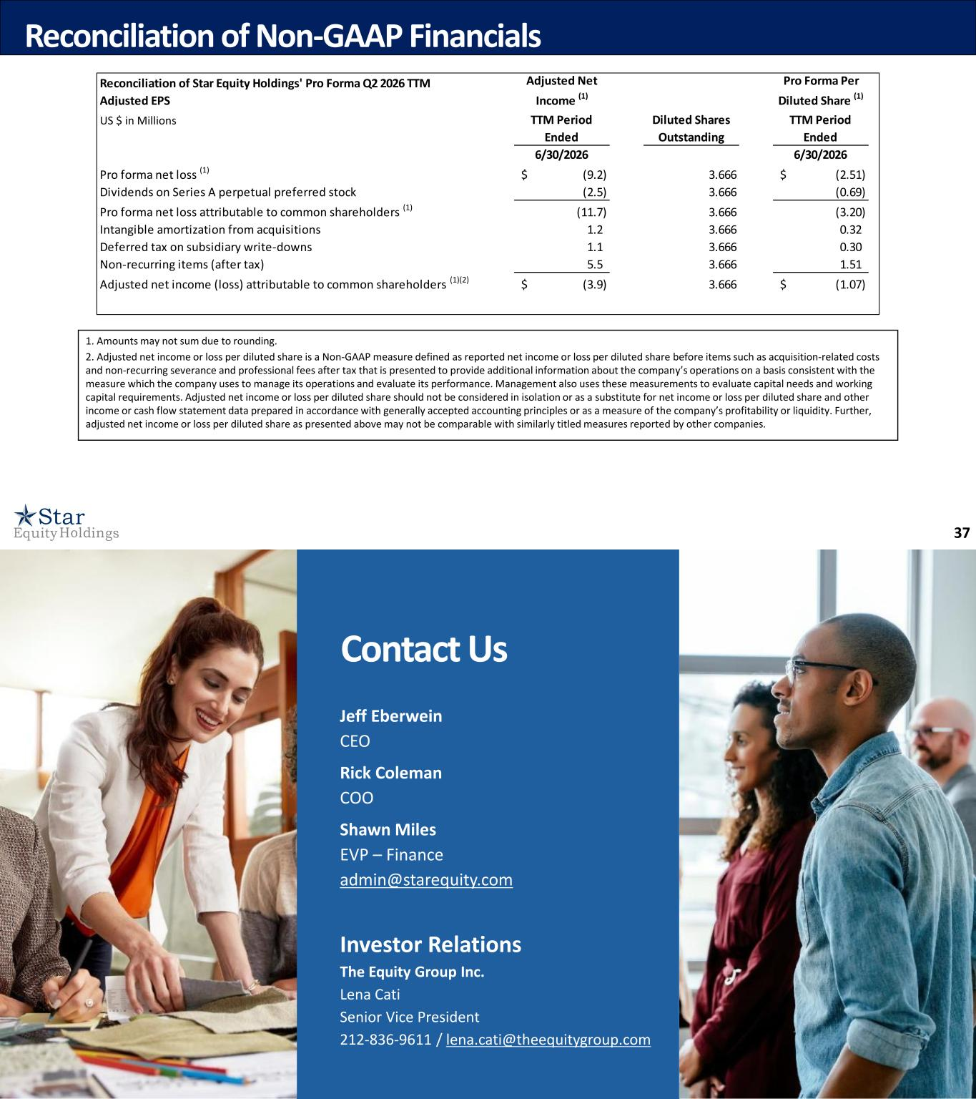
37 1. Amounts may not sum due to rounding. 2. Adjusted net income or loss per diluted share is a Non-GAAP measure defined as reported net income or loss per diluted share before items such as acquisition-related costs and non-recurring severance and professional fees after tax that is presented to provide additional information about the company’s operations on a basis consistent with the measure which the company uses to manage its operations and evaluate its performance. Management also uses these measurements to evaluate capital needs and working capital requirements. Adjusted net income or loss per diluted share should not be considered in isolation or as a substitute for net income or loss per diluted share and other income or cash flow statement data prepared in accordance with generally accepted accounting principles or as a measure of the company’s profitability or liquidity. Further, adjusted net income or loss per diluted share as presented above may not be comparable with similarly titled measures reported by other companies. Reconciliation of Non-GAAP Financials Reconciliation of Star Equity Holdings' Pro Forma Q2 2026 TTM Adjusted EPS Adjusted Net Income (1) Pro Forma Per Diluted Share (1) TTM Period Ended Diluted Shares Outstanding TTM Period Ended 6/30/2026 6/30/2026 Pro forma net loss (1) (9.2)$ 3.666 (2.51)$ Dividends on Series A perpetual preferred stock (2.5) 3.666 (0.69) Pro forma net loss attributable to common shareholders (1) (11.7) 3.666 (3.20) Intangible amortization from acquisitions 1.2 3.666 0.32 Deferred tax on subsidiary write-downs 1.1 3.666 0.30 Non-recurring items (after tax) 5.5 3.666 1.51 Adjusted net income (loss) attributable to common shareholders (1)(2) (3.9)$ 3.666 (1.07)$ US $ in Millions 38 Contact Us Jeff Eberwein CEO Rick Coleman COO Shawn Miles EVP – Finance admin@starequity.com Investor Relations The Equity Group Inc. Lena Cati Senior Vice President 212-836-9611 / lena.cati@theequitygroup.com

